LeVonte Abercrombie

October 22, 2023

Module 1 Assignment 1.2

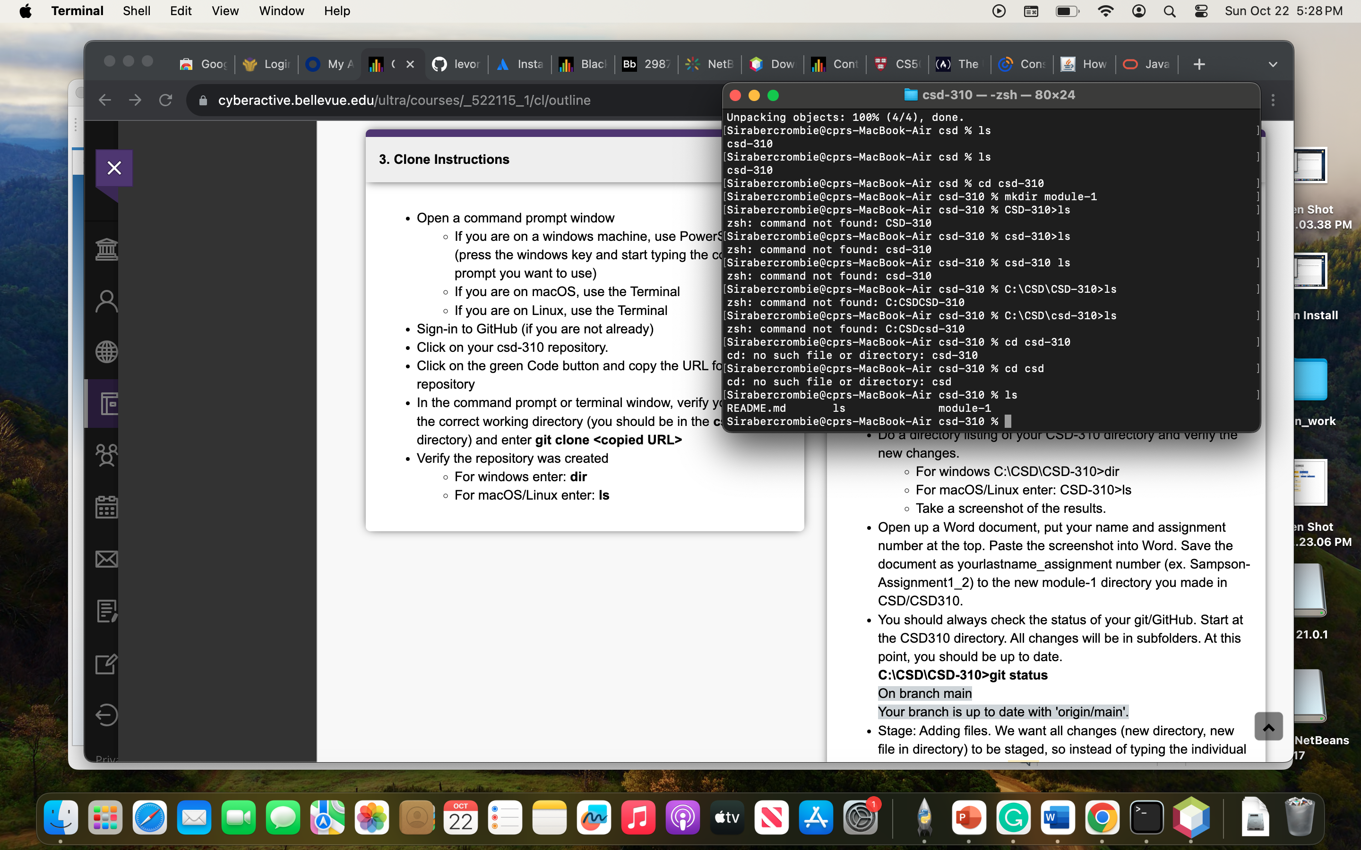

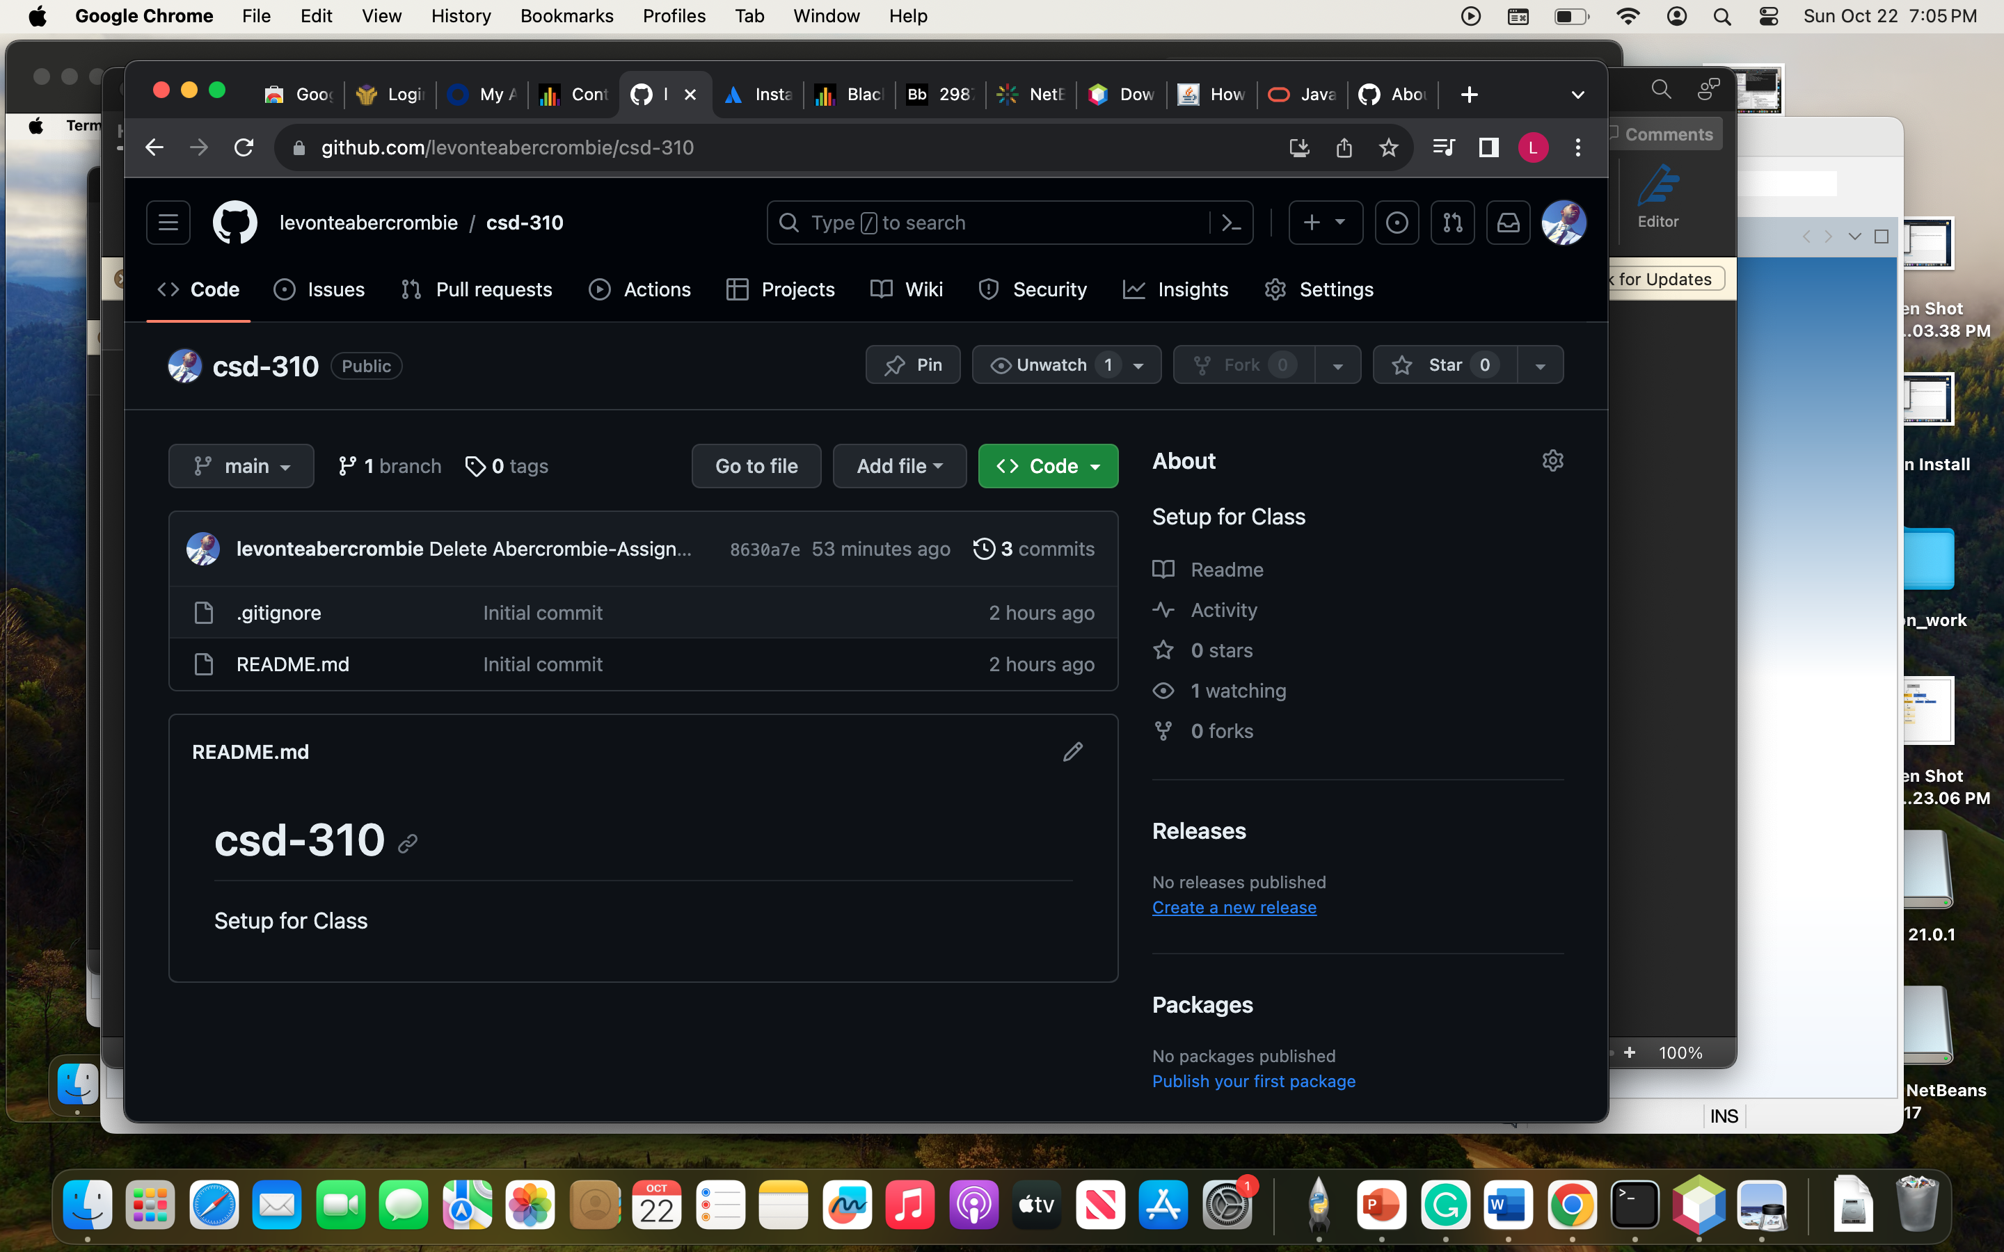

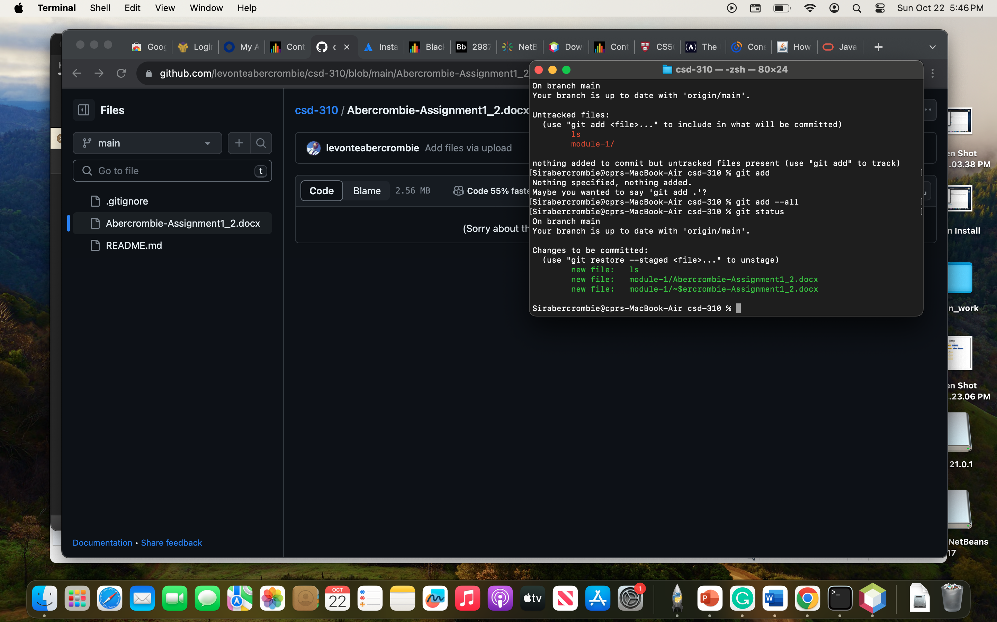I got this far but when I went to the next step I couldn’t figure out my mistake.

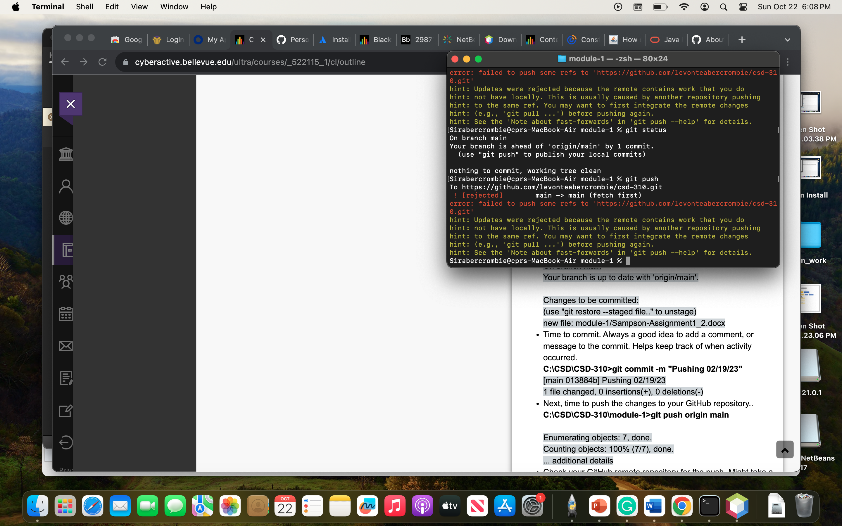

https://github.com/levonteabercrombie/csd-310.git